PECOS COUNTY WATER CONTROL AND IMPROVEMENT DISTRICT No. 1
4375 N Hwy 18 | PO Box 696 | Fort Stockton TX 79735
Phone 432-336-3977 | Fax 432-336-3052  AGENDA | Email: pcwcidI@gmail.com
During the meeting, the Board reserves the right to go into executive session for any of the purposes authorized under the Texas Open Meeting Act, Chapter 551 of the Texas Government Code, for any item on this agenda or as otherwise authorized by law.
The Pecos County Water Control and Improvement District No. 1 will meet in Regular Session on Tuesday, January 10, 2023, at 7:00 p.m. at the Rural Community Building located at 115 W 44th
Lane, Fort Stockton, Pecos County, Texas. The following items will be discussed and/or acted on.
- Call to Order, Invocation and Roll Call.
- Adopt Agenda
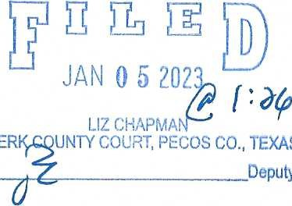
- Welcome the public CLER
TEXAS
Deputy
By
- Open discussion with public and please limit to 3 minutes
- Discuss and/or act on USDA Project.
- Discuss and/or act on Mendel Easement.
- Discuss and/or act on Comanche Creek Lease.
- Discuss and/or act on Gordon Property Matter.
- Discuss and/or act on approval of 2023 budget.
- Discuss and/or act on approving minutes of Special Session meeting held on November 17, 2022.
- Discuss and/or act on approving minutes of Regular Meeting held on December 6, 2022.
- Discuss and/or act on approving Financial Statements.
- Discuss and/or act on approving Accounts Payable.
- Office Manager's Report.
- Managers Report.
- Open discussion with the public and please limit to 3 minutes.
- Adjourn.
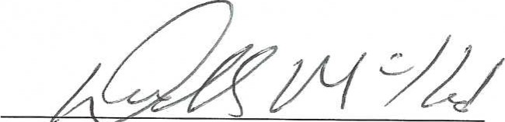
Dudley Mckissack, President
Pecos County Water Control and Improvement District No. 1

